PRO PHYSICAL THERAPY
MEDICAL HISTORY
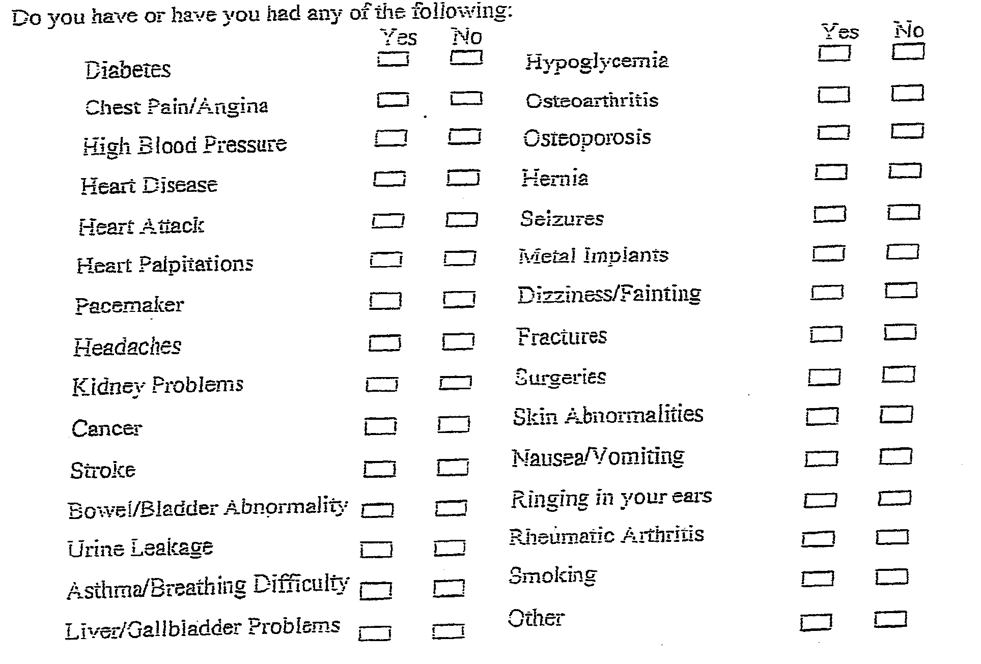
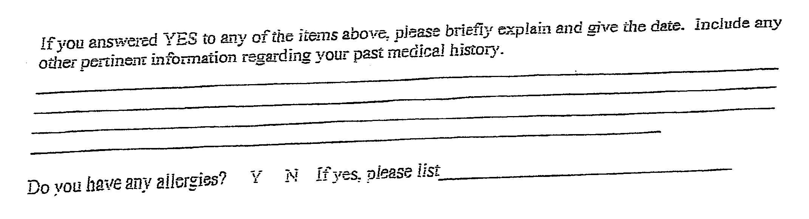

3077 Hwy 371 N. Mantachie, MS 38855
Phone: (662) 282-4949 Fax: (662) 282-4955

